Azure App Service
Azure App Service enables you to build and host web apps , mobile back ends , RESTful APIs
Programming language of your choice
.Net , Node.js , PHP , Java , Python , HTML , Windows Container

Deployment models
Zip/WAR , FTP , Local Git , Azure DevOps , GitHub , BitBucket , DropBox , OneDrive Sync

Operating System : Linux , Windows

App Service Plan : CPU , Storage , Memory – Billing & Features set , it can have multiple App Service associated with it
App service has multiple Deployment slot to swap between different versions of the Application

Web App Resource group , Name , Code , Runtime stack , OS , Region , App Service Plan , SKU and Size (CPU , Memory , Billing , Included Features)

We can scale up and out

Download the publish profile from Azure

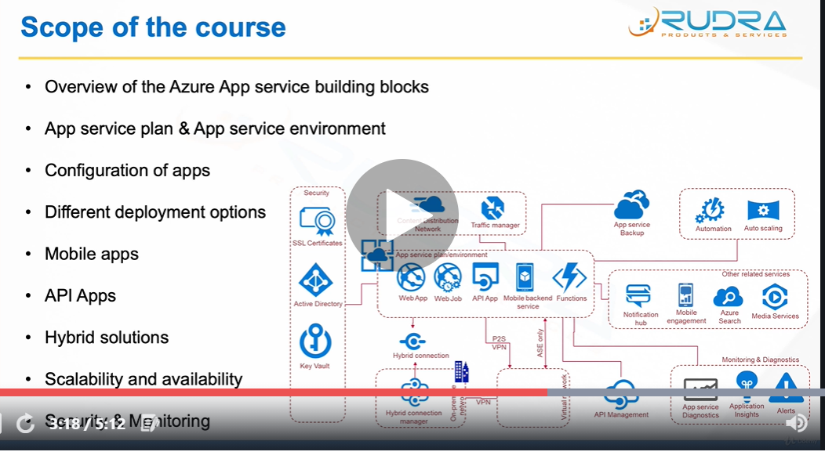

Azure Service Building Blocks

App service plan/environment , App service environment is little more advanced
Notification hub – to push notifications
Azure search
Media services

API Management – throttling , security , useful for commodifying the services and selling to outside world
Point2Site VPN – Apps to interact with virtual network
AppServiceEnvironment – APP’s with in ASE can seamlessly communicate with apps installed on virtual machine,within virtual network
To communicate with App in App service plan & Apps in Onpremise network , one way is Site to Site VPN , another is Hybrid Connection

Automation & Auto Scaling for scaling the apps
High Availability and Performance Traffic manager and Content distribution network
App service backup – for backing up of App services
Monitoring App service diagnostics , Application insights – to monitor different metrics , Alerts
Security SSL Certificates , Active Directory , Key Vault

App Service Plan & App Service Environment

An App Service plan represents set of features and capacity that you can share across multiple apps in same subscription and geographical region .One or more apps can be configured to run on the same computing resources

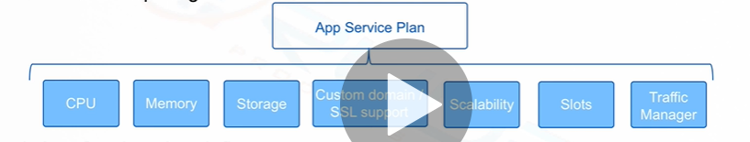

Each App Service plan defines
- Region
- Number of VM instances
- Size of VM instances
- Pricing tier

App service plan
- Shared compute (Free & Shared) : Runs an app on the same Azure VM as other App Service apps , including apps of other customers
- Dedicated compute (Basic,Standard,Prmium and Previmumv2) Only apps in the same App service plan share the same compute resources
- Isolated : This tier runs dedicated Azure VMs on dedicated Azure Virtual Networks , which provides network isolation on top of compute isolation to your apps
- Consumption : This tier is only available to function apps . It scales the functions dynamically depending on workload

App service plan – Environment features
Development framework, File access (local & network drives) , Network access - Application code can use TCP/IP and UDP based protocols to make outbound network connections to internal accessible endpoints that expose external services

Web Apps Multiple languages and framework , DevOps optimizations , Security & Compliance , Visual Studio Integration

App Service Plan Name , Subscription , Resource Group ,Operating System , Location , Pricing tier
Left side navigation - Apps , File system storage , Networking , Hybrid connections , Scale up and Scale out

Create an WebApp
Name, Subscription,Resource Group , App Service Plan , Application Insights (Http errors , user engament,page performance , query performance)
Get publish profile , reset publish profile
Deployment – VS , OneDrive , LocalGitRepository , Github , Bitbucket , Dropbox , External Repository
Transfer the code using FTP protocol also
Deployment slots – production , pre production , dev slot
Application settings - setting up the environment (.net framework)
Authentication/Authorization
Managed service identity
Backup , Custom domains , SSL Settings
Azure CDN , IP Restrictions
WebJobs

Deploying an application into Azure web app with VS

Azure App Service Environment (ASE) is an Azure App Service feature that provides a fully isolated and dedicated environment for securely running App Service apps at high scale

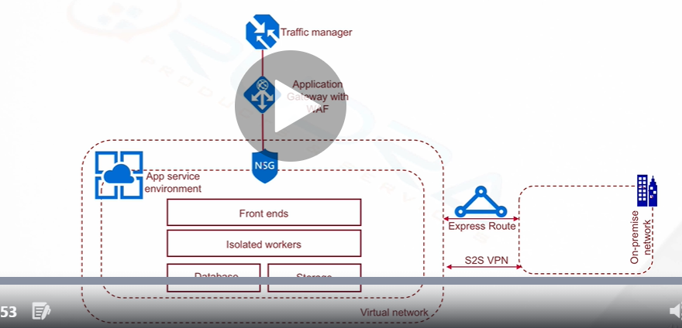

When to go for ASE

Very high scale
Isolation and secure network access
High memory utilization
Apps running on ASEs can have their access gated by upstream devices , such as web application firewalls

Creation of App Service Environment
Name , Subscription , Resource group , Virtual Network , ASE pricing details – very costly

Settings ASE Health , IP Addresses , Front End Scale

We create an App Service Plan into an App Service Environment
Allowed pricing tier for App Service Plan is l1 Isolated

